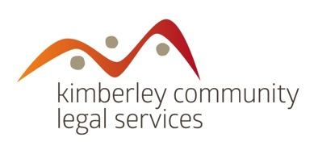

ANNUAL GENERAL MEETING AGENDA
Monday 4 December 2017
3.30pm at Kununurra Country Club
or dial in by phone (02) 4238 5110 access code 538135

- Welcome, acknowledgement of country, apologies
- Overview of the Year

- Confirmation of Minutes of AGM 31 October 2016

- Presentation of Auditor’s Report
- Appointment of Auditor:
“That LBW Chartered Accountants be appointed as the auditor of KCLS for 2017-18”

- Special Resolution – revised KCLS Constitution

“That the members present approve adopting the Amended Model Rules for the Association, as attached, in order to comply with the WA Associations Act 2015”.

- Nominations for KCLS Board 2017/2018
- Acknowledgements and close

